Mark Pratt

CST-247

7/14/20

Professor Pritchard

Activity 2 Screenshots

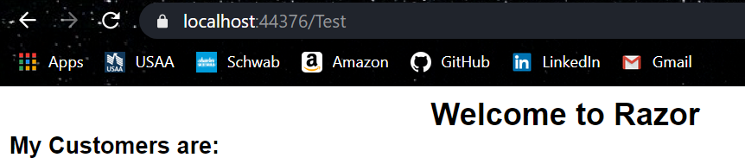

Screenshot 1

Put labels using @html.Label()

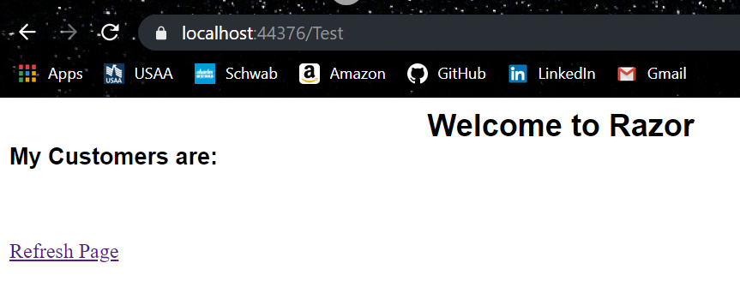

Screenshot 2

Put action link to refresh page using @html.ActionLink()

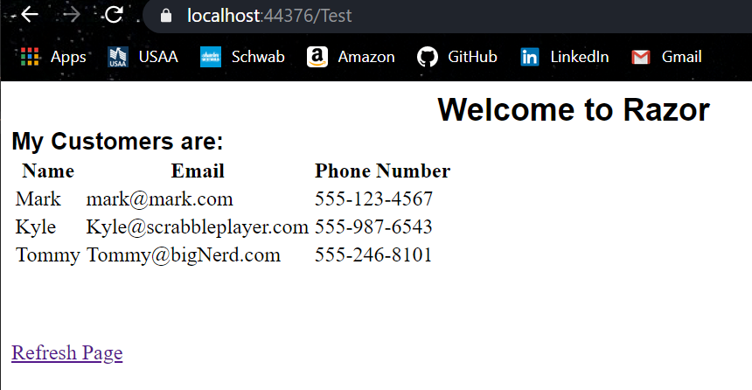

Screenshot 3

Added in a table with usermodels, used foreach construct to display

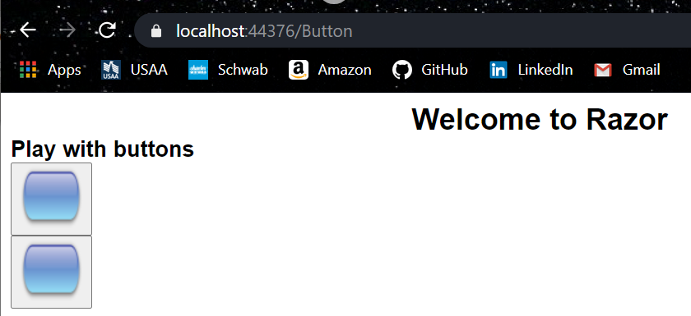

Screenshot 4

Buttons before toggle

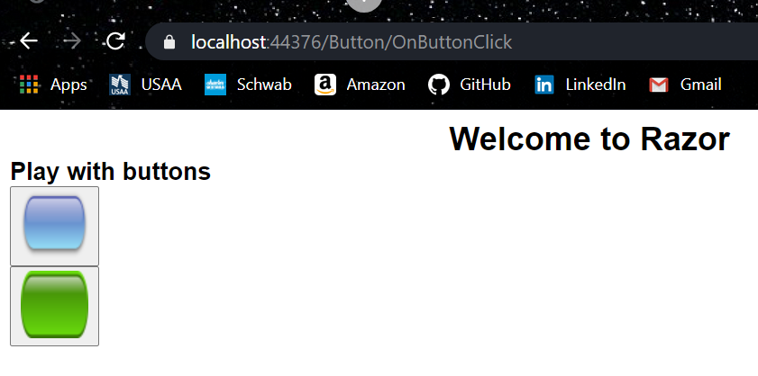

Screenshot 5

Buttons after toggle